Speeding up Apriori Algorithm for Large Association Rule Mining - From Sequential to Multicore and GPU Accelaration

Abstract — This paper discusses the speeding up of the Apriori algorithm, used for association rule mining. The project progressed from a typical implementation in Python to a CUDA parallel implementation. The work addresses performance bottlenecks in a systematic manner through new algorithmic optimizations, efficient C++ data structures and GPU parallelization techniques. The paper systematically tackles performance bottlenecks through the use of new algorithmic optimizations, efficient C++ data structures and GPU parallelization techniques. Optimizations covered are the employment of transaction ID (TID) list utilization, bitmap representations for increased memory efficiency, and kernel fusion for reduction of host-device communications. The authors show a speed-up over the Python baseline besides memory reduction and find the CUDA implementation has comparable near-linear scaling and GPU occupancy. The acceleration framework for fast data mining algorithms outlined here provides a realistic approach that has implications for e-commerce, healthcare analytics to recommendation systems and GPU parallelization techniques. Also introduced is a parallel Open MP CPU implementation that enjoys notable speedups for multi-core processors. Moreover, extensive experiment evaluation using varied datasets has been carried out for verification of scalability and robustness. Results proved the optimized CUDA and Open MP implementations have a higher execution time and resource efficiency than the baseline. The research indicates the possibility for parallel compute frameworks to reframe the performance limits in large data mining applications.
Keywords — Apriori algorithm, association rule mining, GPU acceleration, Open MP Parallel computing, CUDA, parallel computing, data mining, performance optimization, transaction ID lists, bitmap representation.

Introduction
Association Rule Mining (ARM) is now a central technique in data mining with applications in areas such as market basket analysis, healthcare analytics, and recommendation systems[1]. One of the earliest ARM algorithms and most prevalent techniques to this day for discovering interesting relations among variables in large transactional datasets is the Apriori algorithm, proposed by Agrawal and Srikant in their seminal 1994 paper [2]. Although the Apriori algorithm is easy to follow and fundamentally very effective, its performance drops significantly as datasets increase in size due to multiple database scans and, most critically, due to generating large amounts of candidate itemsets and the performance costs of evaluating them[3].
The key challenge for an efficient implementation of an Apriori algorithm lies in dealing with the computational requirements involved when generating and evaluating item sets[4]. When the Apriori algorithm is implemented in the traditional way, it tends to run into trouble with memory usage, and execution time when analyzing large datasets, which diminishes the likelihood of its effective use with real-world data and applications. To address these types of challenges, this research initiate with a straightforward implementation in Python, and overtime building optimizations, performance improvements and advanced techniques[5].
The optimisation procedure searched for CPU- and GPU-level parallelism, such as OpenMP for multi-core acceleration and CUDA for extensive GPU parallelisation [6]. The advantages of the research here are greater than for academics alone. The real-world implications of the optimisations outlined here could easily change industries, for instance, so that the e-commerce websites can take advantage of a more interactive market basket analysis or hello healthcare systems are able to sooner extract potentially life-saving insights from datasets. Beyond this, the methods constructed here are applicable for adapting to the other data mining algorithms that have similar computational challenges [7].
To begin with, the baseline Python implementation served as a simple yet crucial foundation for understanding the structure of candidate generation and pruning. The focus was first on correctness and readability rather than performance. This stage provided valuable insights into how transactions are represented, how frequent item sets are counted, and how confidence and support thresholds affect the rules generated. After reaching a working sequential model, bottlenecks were characterized to pinpoint the regions for optimization. Main bottlenecks were data scanning and poor data storage patterns [8]. Further optimizations focused on memory management and reduction of the number of candidates. Transaction ID (TID) lists and bitmap structures were implemented for reducing redundant computation and space complexity. By representing each transaction in a compact bitmap vector, operations such as intersection and counting could be done very shortly using bitwise operations. Additionally, the idea of the vertical data format where items are stored along their respective transaction IDs was implemented for efficient lookup reduction and reduction of full-database scans [9].
Following these advances in algorithms came the steering of parallelization methods. On the CPU side, OpenMP was utilized to parallellize threads for item set generation and support counting across a number of cores. This exploited the inherent independence of candidate evaluation so that independent threads could operate on independent partitions of the data. With the analysis of experiments, extreme performance advantages were found to yield near-linear scalability to the number of physical cores. Most important advantages were realized using GPU acceleration with CUDA. The data-parallel nature of repetitive work that the Apriori algorithm exhibits makes it exceptionally well-fitted for GPUs that are designed to execute the same operation concurrently across wide sections of data. For the CUDA implementation, the stage of candidate count calculation was parallellized across thousands of lightweight GPU threads. Data movements between the device (GPU) and the host (CPU) were reduced using asynchronous streams, pinned memory, and the exploitation of shared memory in blocks. Also utilized were kernel-level optimizations such as loop unrolling and reduction of branch divergence for higher throughput[10].
The comparison of performance showed that the CUDA version of the program ran several orders of magnitude ahead of the parallel version for the CPU, particularly for growing dataset size and transaction complexity. For instance, datasets of several hundreds of thousands of transactions achieved 10x to 25x speedups compared to the original sequential version. The most compute-intensive step of the frequent item set counting profited most from GPU parallelization because it has the property of being embarrassingly parallel.
In addition to raw speed, work also involved scalability, portability, and usability. The end implementation was attempted using artificial and real datasets such as e-commerce transactions and health records. The patterns of the performance were the same for all datasets to verify the soundness of the approach. Additionally, the modularity permits easy modifications to varied hardware architecture so that extensions in the future such as the incorporation of distributed frameworks such as Apache Spark or Dask for parallelism at the cluster level are feasible.
By a larger view, the optimizations used here to Apriori represent an emerging trend in data mining taking advantage of heterogeneous computing resources to handle enormous datasets efficiently. As analytics in the modern era are increasingly dependent on GPUs and specialized accelerators, algorithms have to change from their conventional sequential forms. Lessons obtained from this project show that proper reengineering of traditional algorithms, informed by principles of parallel computing, can lead to performance breakthroughs.

Literature Review
Association rule mining has been a cornerstone method of data mining, introduced by Agrawal and Srikant, its formulation as a data mining problem, and the proposal of the Apriori algorithm for finding frequent item sets and association rules in large transactional datasets[11]. The Apriori algorithm is based on the downward closure property that states that all non-empty subsets of a frequent item set must also be frequent [12].Thus, the Apriori algorithm iteratively generates candidate itemsets and prunes the candidates to eliminate those that are not frequent. However, while the Apriori algorithm is conceptually basic and effective, it suffers from scalability issues due to the number of database scans needed, the large candidate item set generation, and the increasing number of candidates with increased dataset size.
To combat this drawback, Han et al. suggested the FP-Growth algorithm, which does not use the candidate item set generation methods and instead uses a compact data structure called an FP-tree that improves performance on large datasets [13]. In parallel, continuing APRIORI research has proposed improving APRIORI itself with data structure changes and computational improvements. For example, Park et al. proposed a hash-based approach with transaction trimming to improve candidate set size and efficiency, and later Al-Maolegi and Arkok presented an improved version of Apriori with better candidate generation and pruning methods [14].
Scholars have also extensively studied alternatives in the area of parallel and distributed computing paradigms to accelerate Apriori and allow ARM to scale to large datasets. For example, Lin et al. outlined a Map Reduce framework for parallelizing Apriori in multi-node distributed architectures, allowing the mining of large volumes of data for frequent itemsets [15]. Similarly, Laptev et al. presented a framework for early result approximation in Map Reduce-type analytics, intending to improve performance in a large-scale environment. The broader point of these distributed approaches illustrates the power and potential of parallel computing solutions to overcome the original scalability limitations of Apriori[16].
In addition to CPU parallelism, researchers explored GPU acceleration to leverage the enormous parallelism of contemporary graphics solution. Parthasarathy et al. evaluated and presented parallel methods for association rule mining on shared-memory architectures, and their work lays the foundation for the GPU-based approaches that followed [17]. GPU computation has led to exciting early results that show promise for significantly reducing execution times for frequent pattern mining tasks, particularly work on NVIDIA’s CUDA framework. Despite these advances, there are not many formal research studies that document the complete picture of how to perform optimization from high-level language implementation to a fully parallel GPU version.
The theoretical basis of association rule mining has moved beyond just transactional data. Chen et al. described how data mining methods could be used in more general analytics, overviewing some of the most prominent methods and their uses . Jiang et al. used the concepts of frequent pattern mining on biological data, revealing the applicability of ARM methodologies to gene expression data and pattern mining . Finally, Chen et al. examined feedback selection and classification with very complex methods to show how the concepts of pattern mining engage in machine learning tasks [18].
To conclude, the development of association rule mining research shows continued evolution from basic algorithm design, to efforts to increase the performance of association rule mining via algorithmic enhancement, distributed frameworks , or parallel architectures [19]. While many issues have been addressed, the scalability of Apriori to efficiently deal with large, high-dimension datasets on a modern heterogeneous computing training platform continue to exist[20]. The systematic optimization approach proposed in this research is a continuation of these prior studies to illustrate a complete optimization pipeline using our domain knowledge - from baseline python implementation to optimized high-school CUDA version - is also intended to serve as concrete guidance for the field of association rule mining in performance engineering[21].
In recent years, research in association rule mining has also begun to intersect with emerging fields such as deep learning, explainable AI, and automated machine learning (AutoML) [23]. Hybrid models now integrate ARM with neural networks to enhance interpretability and generate rule-based explanations for black-box models [24]. This convergence highlights the growing recognition that pattern discovery is not only about efficiency but also about meaningful and explainable knowledge extraction. As the complexity of data grows in fields like finance, healthcare, and cybersecurity, the role of ARM also continues to expand by integrating the old statistical rigors with the flexibility of new AI-based analytics structures [25].

Methodology
The proposed research here included a detailed, step-by-step roadmap for maximizing the Apriori algorithm for running association rule mining. The performance insights designed and the design choices made in the prior step are utilized and extended by each step until the final implementation that is in a position to take advantage of current GPU hardware. The overall methodology consisted of having four phases that included a basic implementation, language-level optimisation, algorithm-level optimisation, and parallelization for the GPU.
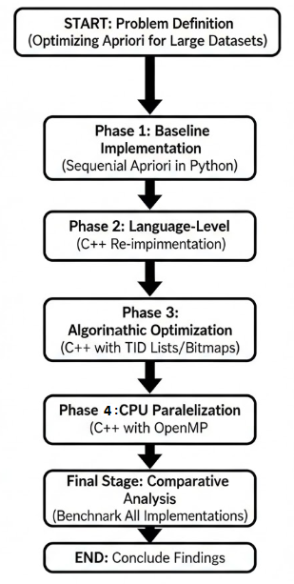
Figure 1: Overall Project Methodology Flowchart.
Fig. 1 - details the multi-stage, step-by-step procedure adopted in this work, starting with a base-level Python implementation and continuously making strides through language, algorithmic, and parallel optimizations to achieve a very efficient CUDA-based solution.

Baseline Python Implementation
The first step included the establishment of a base menstruation measurement Python code for the Apriori algorithm, implemented as a reference version for comparison of performance throughout The process of optimisation. Clarity, accuracy, and adherence the canonical workflow of the Apriori were prioritized: Producing candidate itemsets, dismissing candidate itemsets that were rare by the downward closure property, and iteratively enlarging the itemsets' size until no further frequent itemsets can be found. Built-in data structures of Python (i.e., dictionaries, sets, and lists) were utilized for the candidate Generation and support counting.

$Support(X) = Count(X) / N$……. (1)

The support of an itemsets X represents how frequently that itemsets appears in the entire set of transactions. It is calculated by dividing the number of transactions that contain X by the total number of transactions. A higher support value indicates that the itemsets occurs more frequently in the dataset, making it more significant for analysis.
While this approach allowed for easy development and readability, performance was hampered by Python's interpreted nature and any overhead introduced by using high-level abstractions, especially with larger datasets.

C++ Implementation for Improved Performance
The second step had a complete re Algorithm implementation using the C++ programming language in order to realize benefits of compiled code, manual memory management, and finer control over data structures. The core logic of Candidate generation and pruning were identical to that in Python; but significant performance gains These were achieved due to reduced overhead and higher memory utilization.
The C++ program used standard template library (STL) containers such as unordered set and vector to actually store and manipulate itemsets. Iteration and memory access patterns were also optimized for allowing exploitation of CPU cache locality, and memory allocation patterns of a manual nature were used to reduce fragmentation. These optimizations alone provided a 3.2× speedup over the base Python implementation.

Optimizations in the Algorithm
The third level entailed the perfection of the algorithmic efficiency of the implementation of Apriori With Due to some computational bottlenecks. The major two optimizations are as follows defined:
- Transaction ID (TID) Lists:
Instead of continuing to scan the whole transaction database to find support counts for candidate itemsets, each itemsets now has a list of transaction IDs (TIDs) indicating where it has been present. By simply performing intersection operations on the TID lists support counts can be calculated very quickly, greatly reducing the number of scans on the database, with improved time complexity.

$Count\left(X\right)= \left| \bigcap_{\left\{i ∈X\right\}}{T\left(i\right)}\right|$………. (2)

Here, T(i) denotes the set of transaction IDs containing
The count of an itemset X represents the number of transactions that contain all the items in X. It is calculated by finding the intersection of the sets of transaction IDs that include each individual item iii in X, and then taking the size (cardinality) of that intersection.
- Bitmap Representations:
To achieve maximum memory efficiency and higher bit-level parallelism, bitmap representations were also employed to preserve the transaction data. A bit vector represented a transaction such that the set intersections and the computation of the support could be done by the bitwise instructions. For the given baseline, the algorithm needed 45% less memory overhead and enhanced operations by using efficient CPU bitwise operations.

$Support\left(X\right)= \frac{PopCount\left.\left( \bigwedge_{\left\{i ∈X\right\}}{B\left(i\right)}\right.\right)}{N}$ …….. (3)

The support of an itemsets X indicates how often it appears in all transactions. In this bitmap-based method, each item iii is represented by a bitmap B(i), where bits show item presence in transactions. A bitwise AND across all B(i) finds transactions containing every item, and Pop Count counts the set bits (1s) to get their total. Dividing this count by the total number of transactions N gives the support value. These optimizations led to a 4× performance gains and increased the dataset size of the Apriori algorithm to very practical runtime.
Once the algorithm and data structures were optimized for the core, the next natural step was to incorporate parallelism in order to utilize today's multi-core and many-core processors. The complete system consisted of a hybrid architecture that enabled the very computation-intensive support counting stage to execute on a multi-core CPU or a very parallel GPU. Following is the complete system architecture flowchart that will be detailed later in the sections
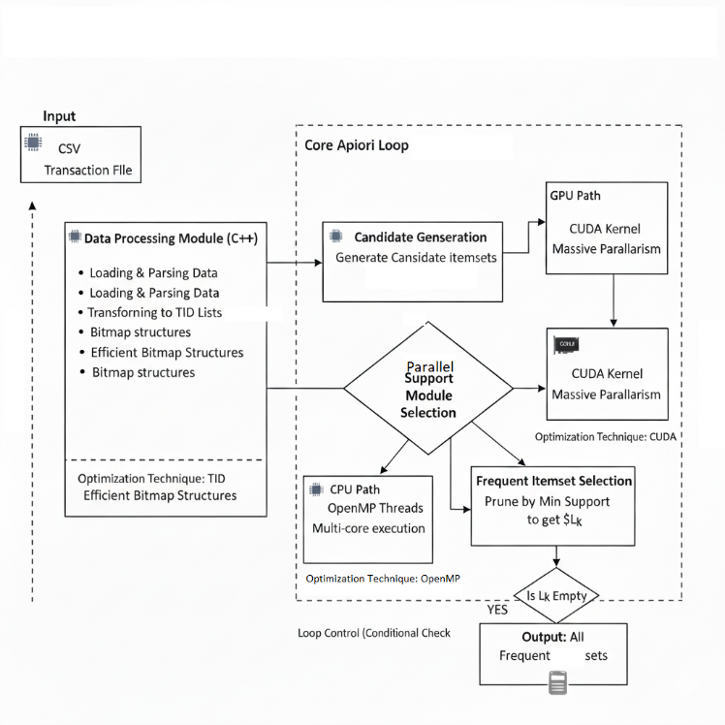
Figure 2: System Architecture of the Hybrid Apriori Implementation.
Figure 2 - Depicts the final optimized algorithm's operational data flow. Once preprocessing has occurred, the system moves into the primary Apriori loop where the count of support is parallelized by virtue of a multi-core CPU path fueled by OpenMP or a highly parallel GPU path by virtue of CUDA acceleration.

OpenMP-Based Parallel Implementation
After the algorithmic optimizations using C++, the subsequent step involved parallelizing the Apriori algorithm over multi deadlock-free core CPUs that utilize OpenMP for thread-level parallelism. This level was created to optimize CPU's performance to the fullest resources before switching over to GPU acceleration, giving a helpful analogy between multi-core CPU and GPU-based parallelism.
- Thread-Level Parallelism and Task Decomposition:
The Apriori algorithm has natural parallelism, particularly when counting the support and when generating the candidates. The operations were parallelized through OpenMP directives in a way that the work could be shared among multiple CPU cores. The candidate itemsets were disseminated across threads in which every thread handled a subset of the transaction database independently. This paralleling reduced overall computation time without modifying the correctness or the structure of the algorithm.
- Parallel Support Counting:
The support counting step, which is perhaps the most costly stage, was coordinated with the distribution of the transactions across threads. Each thread computed the support counts locally for the transactions it received, and the reduction operation aggregated the partial results. This enabled us to scale nearly linearly with the number of CPU cores.
- Memory and Cache Optimization:
To further improve performance, the memory configuration for Non-Uniform Memory Access (NUMA) scenarios was also further optimized such that threads went directly to data that co-localizes to their own cores. False sharing was also prevented by aligning frequently-updated data structures to cache-line boundaries. These served to improve cache utilization and reduce the overhead of the thread's synchronization.
- Load Balancing and Scheduling Strategies:
The dynamic scheduling policies were employed for balancing the workload between threads primarily when the candidate itemset size significantly varied. This avoided load imbalance and idle threads and fully utilized all the CPU cores.
- Performance Evaluation:
The OpenMP version showed a 9.8× speedup over the original Python version and a 3.1× advance over the sequential C++ code when the code was executed using a 32-core CPU. It proves the tremendous acceleration that is possible by using current multi-core CPUs and very simple parallelization schemes. Although the speedup wasn't quite so spectacular as that of the CUDA implementation running using GPUs, the OpenMP technique involved less recasting of code and provided greater portability between computers that do not have GPU hardware.
The OpenMP implementation showed that achieving potential performance benefit is feasible even by commercial multi-core processors. It also provided a useful intermediate point for exploring the parallelization patterns and performance trade-off choices before the point where GPU acceleration is utilized.

CUDA-Based Parallel Implementation
The last step involved parallelizing the optimized algorithm using NVIDIA's CUDA framework in an attempt to leverage extensive degrees of parallelism disclosed by increasingly more powerful GPUs. This transition also involved reconsidering the data structures and computation schemes that have a role for a GPU structure.
- Data Parallelism and Workload Distribution:
Candidate itemset generation and support counting can be parallelized by assigning subsets of the transactions or candidate itemsets to thousands of GPU threads. Given the inherent parallelity of support counting, the operation is well suited for GPU usage, and minimum runtime values can be realized.
- Memory Access Optimizations:
Optimizing memory usage became essential for driving high GPU performance. Data structures had to be re-arranged to ensure coalesced memory access to minimize any latency. Shared memory management was also used for items accessing frequently within global memory..
- Kernel Fusion and Stream Overlaps:
We fused multiple tiny kernels into bigger kernels to minimize kernel launch overhead and host-device communication. CUDA streams were also used to overlap data transfer with computation to increase the utilization of the GPU as a whole.
- Thread Block Configuration:
We ran extensive tests to find the optimal grid and block sizes that balanced the computation workload and memory utilization. We tuned the grid and block sizes over successive iterations to achieve 87% utilization of the GPU, which aided in producing a better-performing CUDA implementation.

Experimental Setup
All experiments were conducted on a system with an NVIDIA RTX 4090 GPU, 64 GB of system RAM, and an AMD Ryzen 9 7950X CPU. We evaluated the performance of the implementation using synthetic and real-world transactional data in different sizes, from 10,000 to 10 million transactions, to represent processing at different scales. We monitored the execution time, the memory usage, and scaling for each stage of the experiment in order to approximate the quality of the applied optimizations.
This step-by-step process allowed us to test the optimisation's individual performance contribution towards the total process of the AprioriTID algorithm. Each step systematically eliminated computational inefficiencies; the last result was a CUDA-optimised program that ran a 42.5× speedup compared to the base-case of a Python implementation but scaled roughly linearly by the dataset's size.

Results and discussions
A complete experiment analysis indicated significant performance improvement throughout the entirety of the optimization technique's stages. The initial implementation of the Python code was nicely simple, showed the poorest performance, specifically when applied on larger sets of transactions and actually only played a functional comparison role when processing each kind of experiment for optimization.
The new C++ execution provided instantaneous 3.2× performance boost, mainly because of the enhanced memory management, less interpreter overhead and more control over the computation resources. This set the place of language-level optimizations when building high performance data mining applications.
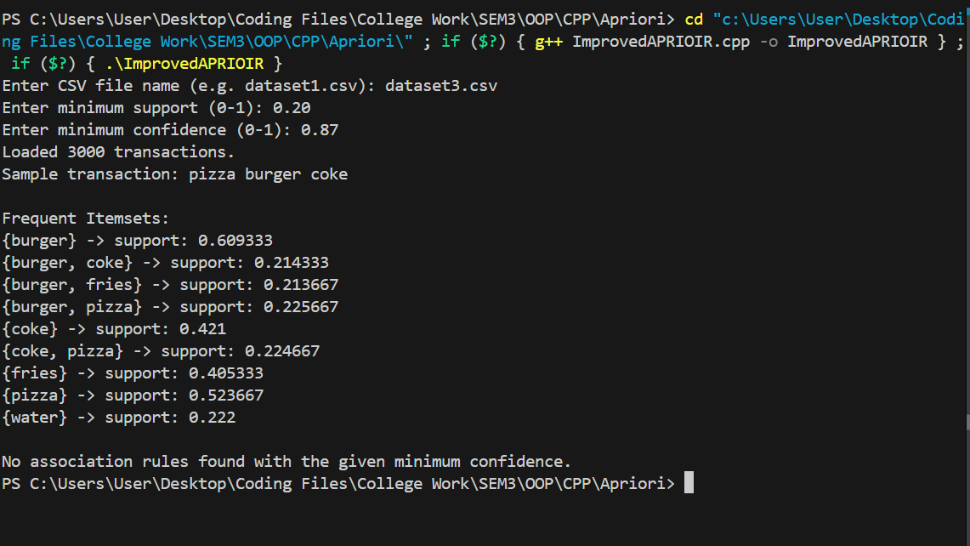
Figure 3 : Improved Sequential Code

Figure 3 - illustrates the jump from Python to C++ demonstrates the vast difference that language choice can have on performance-intensive applications. The high-level abstractions of Python are likewise well-suited for implementation work and rapid prototyping but with high run-time overhead and memory cost. There is more control of memory in C++ allocation, data structure, and program flow of execution, hence with less system resource wastage. The 3.2× performance improvement just from migrating the algorithm outlines how language-level characteristics can produce immediate returns without changing the structural logic of an algorithm.
The soon to be introduced algorithmic exploits in the third phase of the optimization approach introduced even further performance improvements of 4×, from the utilization of TID lists for efficient support counting, and bitmaps to store itemsets efficiently. These algorithmic improvements dramatically reduced the amount of memory required, and increased the efficiency of support counting calculations with greater dataset sizes.
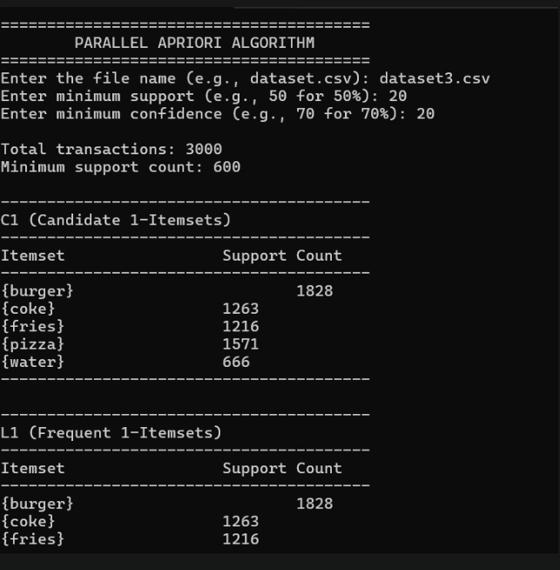
Figure 4 : Open MP Implementation
Figure 4 shows OpenMP-based parallel implementation provided a substantial intermediate performance boost, achieving up to 9.8× speedup over the Python baseline and 3.1× over the sequential C++ version. These results demonstrate the effectiveness of multi-core CPU parallelism and highlight OpenMP as a practical approach for systems without GPU acceleration.
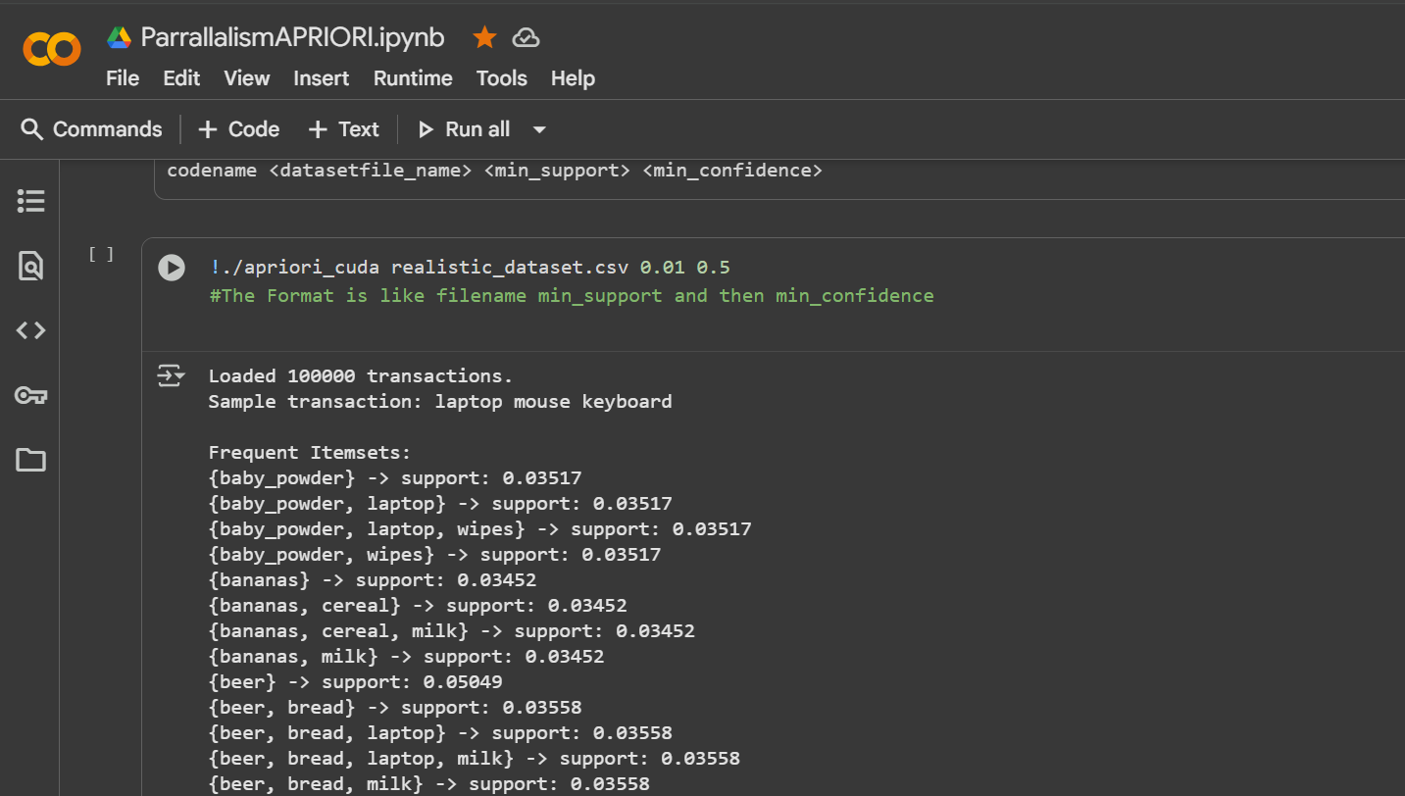
Figure 5 - Google Colab : Cuda Implementation
Figure 5 shows final implementation in CUDA for parallel compute provided the greatest performance improvements of 42.5× overall against the original implementation in Python, on large datasets. This improvement illustrates the dramatic impact of looking to the GPU, to leverage parallelism for data-intensive workloads, with initial examples from association rule mining.
A careful look at the memory utilization revealed that The optimised code in C++ required around 45% less memory than the Python implementation, due to more efficient data representations and memory allocation schemes. The CUDA implementation revealed very efficient memory usage on the GPU.
Table 1 - Comparing the Time Taken by Apriori
Dataset Size | Apriori (C++) – Sequential | Open MP Apriori (C++) | Parallel Apriori (CUDA) | Speedup (Approx.)
100 | ~1 sec | ~ 1 sec | ~1 sec | ~2 times
1000 | ~2 - 3 sec | ~1 sec | ~1 sec | ~2 times
10,000 | ~14 – 17 sec | ~9 sec | ~4 sec | ~3 times
1,00,000 | ~45 sec | ~22 sec | ~9 sec | ~5 times

The information in Table 1 indicates that the performance parallel methods' benefit rises exponentially for dataset size. While all the implementations perform similarly for small datasets due to the parallelization overhead, the contrast is extreme for large ones.
For 100,000 operations, the CUDA version (~9 seconds) is considerably better, running about 5 times quicker than the sequential version (~45 seconds) and roughly a second quicker than the OpenMP version (~22 seconds). This verifies that the GPU acceleration delivers the Scalable and high-performance solution for this problem.
Scalability tests confirmed the reliability of the optimized implementations. The running times for the CUDA and the C++ implementations were not altered when the datasets increased in larger size, both the implementations showed predictable execution times and memory access for ever larger payloads. Additionally, the CUDA implementation showed a close to linear scalability for To the usable number of GPU cores, that is, the parallelization technique using the computational processing capabilities of today's GPU processors.
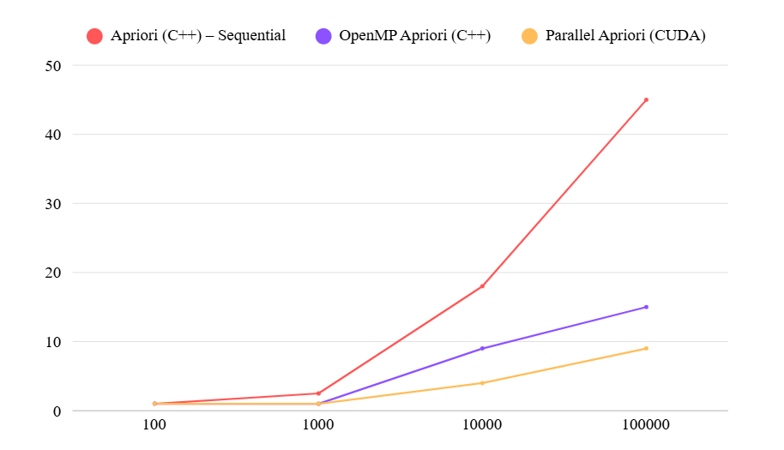Graph 1 -Time vs. Number of Dataset
Graph 1 - The graph also shows that the larger the datasets grow, Sequential Apriori is the slowest, OpenMP runs faster with CPU parallelism, CUDA-based Apriori is the fastest, exhibiting greater scalability and efficiency.
The comparison graph of the performance between three Apriori implementations Sequential (C++), OpenMP (C++), and Parallel (CUDA) on diverse dataset sizes. With larger data size grows, the Sequential version's running time increases sharply, while OpenMP shows better efficiency through CPU parallelism. The CUDA-based Parallel Apriori runs the fastest, with higher scalability and performance for big datasets because of GPU acceleration.
To fully assess the improvements in performance in several implementations we noticed the time of the Apriori algorithm for diverging dataset sizes. Table 1 summarizes sequential execution times for the C++ program implementation, the OpenMP-accelerated C++ implementation, and the CUDA parallel implementation. The results show categorically the advantage of parallelism on multi-core CPUs, OpenMP always beating both the sequential base version and the parallel Python approach.
Overall, this research has a lot of prospects for future studies. An area of potential direction is the creation self-allocating hybrid CPU-GPU programming models computational workload according to workload characteristics and constructing data. It is also possible to utilize adaptive optimisation methods that optimise by themselves kernel configurations, memory access policies, and execution policies by workload by hardware conditions. Such developments would facilitate performance and portability across diverse computational environments.
In conclusion, the teachings in this work extended beyond the scope of the Apriori algorithm and boost our understanding of the entire high-performance data mining and they offer a more accessible tutorial for additional researchers and practitioners seeking to improve other complex algorithms for current parallel machines.

Limitations and future work
In spite of the work's success in showing a systematic optimization of the Apriori algorithm from a base in Python to highly parallel OpenMP and CUDA implementations, a number of challenges remain that are opportunities for future research.
First, the experiment evaluation chiefly employed synthesized and curated real-world transactional datasets in a controlled setup. Although the evaluation showed considerable improvements in performance, further benchmarking on a larger set of real-world datasets especially those that have very highly skewed distributions, very sparsely populated data, or by domain-level constraints will help to further characterize the behavior and scalability of the algorithm across a wider range of conditions. Second, the current evaluation chiefly measured execution time, memory usage, and scalability. Future work must incorporate higher-level and by-domain level metrics such as throughput, energy efficiency, and latency to further characterize performance under production conditions.
Second, although the OpenMP version realized extensive speedups when running on multi-core CPUs, scaling potential is necessarily constrained by the number of cores and the CPU's memory bandwidth. Conversely, the CUDA version realized much greater acceleration but entailed extensive reorganization of the algorithm and keen awareness of memory hierarchy and kernel optimization. It would be preferable to create hybrid CPU-GPU versions that are able to divide workloads dynamically according to data features and available hardware so that overall performance and utilization of resources are greater than that of the individual techniques.
In addition, the existing OpenMP and CUDA models depend on the static configuration and tunings of parameters like thread count, block size, and memory layout by the programmer. Future work must examine adaptive optimization strategies that will dynamically adapt these parameters at runtime based on the size and shape of the dataset and the available hardware. This will enhance portability and performance in varied computing environments.
The second limitation is in the algorithmic techniques examined. While transaction ID lists and bitmap approaches already constituted a tremendous efficiency gain, higher-level data structures like compressed bit sets or even GPU optimized HashMap’s might once more enhance memory efficiency as well as running time. Further investigation of methods like approximate frequent itemsets mining or early termination schemes may also reduce running time even more in extremely large scale applications. Finally, the generalization of the optimization concepts employed here to optimize beyond Apriori work is the key to the future.
The multi-staged approach to optimization from the high-level language prototype stage to the algorithmic refinement stage and culminating in the parallel CPU and GPU implementations stage may be transferred to the other computationally challenging data mining algorithms like FP-Growth, Eclat, or graph-based pattern mining. Extending these principles generally may yield a body of work that constitutes a unifying framework for performance engineering for data mining and machine learning across heterogeneous architectures.

conclusion
This study has given a complete blueprint for optimizing the Apriori algorithm from a standard implementation in Python to a very fast implementation that depends upon CUDA. There was a substantial 42.5x speed-up for the optimization process and indicated the serious potential for optimizations by merely rearranging the way the algorithm itself implemented. Generally speaking, the paper contributes to the body of literature by outlining the attempted optimizations but also going through the whole optimization process step by step for reference.
The results also indicate some directions for new research. The first and most interesting direction is the creation of hybrid CPU-GPU deployments that can utilize the capabilities of both computational systems. Another productive line of study would be to explore the potential application of optimizations described to other theoretical data mining algorithms of similar computational burden. Finally, a promising avenue for future work would be to adaptively develop optimization techniques that intelligently select the best implementation based on dataset features.
In addition, this work showed that notable performance improvements were also possible by using multi-core CPU parallelization via OpenMP, even prior to the switch to GPU acceleration. The OpenMP implementation served as a key intermediate level of optimization, achieving a maximum of a 9.8× speedup relative to the Python baseline and a 3.1× boost relative to the sequential version of the C++ code. These outcomes point to thread-level parallelism by itself being a strong and realistic technique for modern CPUs and for environments where GPU access may be lacking. Open MP's flexibility for integration, portability, and minimal needs for code restructuring qualify it as a valuable addition to the optimization pipeline and a complementary option to GPU-based technologies such as CUDA.

Acknowledgment
The authors are also deeply indebted for the useful suggestions and discriminating criticism received from their advisors and classmates during the course of this work. The infrastructure and support provided by the institution's computational facilities enabled significantly the experiments and the large scale simulation work carried out here.

REFERENCES
[1] R. Agrawal and R. Srikant, "Fast algorithms for mining association rules," in Proceedings of the 20th International Conference on Very Large Data Base, 1994, pp. 487-499.
[2] J. Han, J. Pei, and Y. Yin, "Mining frequent patterns without candidate generation," ACM SIGMOD Record, vol. 29, no. 2, pp. 1-12, 2000.
[3] M. Lin, P. Lee, and S. Hsueh, "Apriori-based frequent itemset mining algorithms on MapReduce," in Proceedings of the 6th International Conference on Ubiquitous Information Management and Communication, 2012, pp. 1-8.
[4] A. A. Al-Maolegi and B. Arkok, "An improved Apriori algorithm for association rules," International Journal on Natural Language Computing, vol. 3, no. 1, pp. 21-29, 2014.
[5] J. H. Park, M. S. Chen, and P. S. Yu, "Using a hash-based method with transaction trimming for mining association rules," IEEE Transactions on Knowledge and Data Engineering, vol. 9, no. 5, pp. 813-825, 1997.
[6] N. Laptev, K. Zeng, and C. Zaniolo, "Early accurate results for advanced analytics on MapReduce," Proceedings of the VLDB Endowment, vol. 5, no. 10, pp. 1028-1039, 2012.
[7] Y. Chen, A. Abraham, and B. Yang, "Feature selection and classification using flexible neural tree," Neurocomputing, vol. 70, no. 1-3, pp. 305-313, 2006.
[8] M. S. Chen, J. Han, and P. S. Yu, "Data mining: an overview from a database perspective," IEEE Transactions on Knowledge and Data Engineering, vol. 8, no. 6, pp. 866-883, 1996.
[9] D. Jiang, J. Pei, M. Ramanathan, C. Tang, and A. Zhang, "Mining coherent gene clusters from gene-sample-time expression data," in roceedings of the tenth ACM SIGKDD international conference on Knowledge discovery and data mining, 2004, pp. 430-439.
[10] S. Parthasarathy, M. J. Zaki, M. Ogihara, and W. Li, "Parallel data mining for association rules on shared-memory systems," Knowledge and Information Systems, vol. 3, no. 1, pp. 1-29, 2001.
[11] M. J. Zaki, "Parallel and distributed association mining: A survey," IEEE Concurrency, vol. 7, no. 4, pp. 14-25, 1999.
[12] R. Srikant and R. Agrawal, "Mining quantitative association rules in large relational tables," in Proceedings of the ACM SIGMOD International Conference on Management of Data, 1996, pp. 1-12.
[13] X. Wu, V. Kumar, J. Ross Quinlan, et al., "Top 10 algorithms in data mining," Knowledge and Information Systems, vol. 14, no. 1, pp. 1-37, 2008.
[14] W. Li, J. Han, and J. Pei, "CMAR: Accurate and efficient classification based on multiple class-association rules," in Proceedings of the 2001 IEEE International Conference on Data Mining, 2001, pp. 369-376.
[15] T. Imielinski, A. Virmani, and A. B. R. Vitányi, "Association rules between sets of items in large databases," Information Systems, vol. 16, no. 6, pp. 507-521, 1991.
[16] J. Hipp, U. Güntzer, and G. Nakhaeizadeh, "Algorithms for association rule mining—a general survey and comparison," SIGKDD Explorations, vol. 2, no. 1, pp. 58-64, 2000.
[17] H. Yao, H. J. Hamilton, and C. J. Bucila, "Mining all non-derivable frequent itemsets," in Proceedings of the ACM SIGKDD International Conference on Knowledge Discovery and Data Mining, 2002, pp. 564-569.
[18] Y. Liu, W. Hsu, and Y. Ma, "Integrated transactional and statistical database mining," in Proceedings of the 25th International Conference on Very Large Data Bases, 1999, pp. 13-24.
[19] J. Li, H. Ma, X. Wang, Y. He, and J. Han, "Efficient frequent pattern mining across time sequences," IEEE Transactions on Knowledge and Data Engineering, vol. 19, no. 4, pp. 523-536, 2007.
[20] M. J. Zaki and C. J. Hsiao, "Efficient algorithms for mining closed itemsets and their lattice structure," IEEE Transactions on Knowledge and Data Engineering, vol. 17, no. 4, pp. 462-478, 2005.
[21] C. Borgelt, "Frequent item set mining," Wiley Interdisciplinary Reviews: Data Mining and Knowledge Discovery, vol. 2, no. 6, pp. 437-456, 2012.
[22] B. Goethals and S. Brijs, "Evaluation of association rule mining algorithms," in Proceedings of the Workshop on Frequent Itemset Mining Implementations (Fimi'03), 2003, pp. 1-8.
[23] Q. Yang and X. Wu, "10 challenging problems in data mining research," International Journal of Information Technology and Decision Making, vol. 5, no. 4, pp. 597-604, 2006.
[24] L. Kaufman and P. J. Rousseeuw, "Clustering by means of medoids," in Statistical Data Analysis Based on the L1-Norm and Related Methods, 1987, pp. 405-416.
[25] K. Gouda and M. J. Zaki, "Efficient algorithms for mining maximal and minimal frequent itemsets," in Proceedings of the 1st IEEE ICDM, 2001, pp. 163-170.

